

**Major Project On**

**Multilabel Classification Using Deep Neural Network**

**Gaurav Kumar**

Department of Computer Science & Engineering

Sikkim Manipal Institute of technology

[gaurav_201800295@smit.smu.edu.in](mailto:gaurav_201800295@smit.smu.edu.in)

**Aditi Karmakar**

Department of Computer Science & Engineering

Sikkim Manipal Institute of technology

[aditi_201800107@smit.smu.edu.in](mailto:aditi_201800107@smit.smu.edu.in)

Guided by:

**Mrs.ChitrapriyaNingthoujam**

Assistant Professor

Department of Computer Science & Engineering

Sikkim Manipal Institute of technology

[chitrapriya.n@smit.smu.edu.in](mailto:chitrapriya.n@smit.smu.edu.in)

**TABLE OF CONTENT**

|  |  |  |
| --- | --- | --- |
| **SL NO** | **TITLE** | **PAGE NO.** |
| **1** | **Abstract** | **2** |
| **2** | **Introduction** | **2** |
| **3** | **Literature Survey** | **3-4** |
| **4** | **Problem Definition** | **4** |
| **5** | **Solution Strategy** | **5-6** |
| **6** | **Design** | **7** |
| **7** | **Progress Update** | **8-11** |
| **8** | **Results** | **12-13** |
| **9** | **Work to be done** | **13** |
| **10** | **Gantt Chart** | **14** |
| **11** | **References** | **15** |

**Abstract**

Feature extraction is a well-known method for lowering computing complexity and improving multi-label picture classification accuracy.When it comes to automating the process of creating meta data or offering suggestions to consumers based on features in their photographs, image labelling comes in useful.

After creating a dataset consisting of 10 distinct classes comprising photographs of various genres, the goal of this project is to extract features from images using CNN and label them using KNN methods.

**Introduction**

**Image Classification**

Image classification involves the extraction of features from the image to observe some patterns in the dataset. Using an ANN for the purpose of image classification would end up being very costly in terms of computation since the trainable parameters become extremely large.

**Convolutional Neural Network(CNN)**

The convolutional neural network (CNN) is a class of **deep learning neural networks**. CNNs represent a huge breakthrough in image recognition. They’re most commonly used to analyze visual imagery and are frequently working behind the scenes in image classification. We will be solving a multi classification “: butterflies, chess, cups, food, landscape, plates,Pokémon, pollen grains, spoons, sports” using Convolutional Neural Network(CNN)

**Multi-Label Classification with Deep Learning**

Multi-label classification is a predictive modelling task that involves predicting zero or more mutually non-exclusive class labels.

Neural network models can be configured for multi-label classification tasks

**LITERATURE SURVEY**

|  |  |  |  |
| --- | --- | --- | --- |
| **SL NO** | **PAPER AND YEAR OF PUBLICATION** | **FINDINGS** | **RELEVANCE TO PROJECT** |
| 1. | CNN-RNN: A Unified Framework for Multi–Label image Classification (2016) | The CNN part extracts semantic representations from images; the RNN part models image/label relationship and label dependency | The proposed framework combines the advantages of the joint image/label embedding and label co-occurrence models by employing CNN and RNN to model the label co-occurrence dependency in a joint image/label embedding space. |
| 2. | Automatic X-ray COVID -19 Lung Image Classification System based on Multi-level Thresholding and Support Vector Machine(2020) | Classifies the corona affected X-ray images from others through usage of the deep features. The technique is useful for the clinical practitioners for early detection of COVID-19 infected patients | The model presents high accuracy where the average sensitivity, specificity and accuracy of the lung classification were 95.76%,99.7% and 97.48% respectively. |
| 3. | Visual Attention in Multi-Label Image Classification (2019) | Results show that the new saliencysub-network improves multilabel image classification performance. | Analysisofthe correlation between visual attention and multi-label image classiﬁcation. |
| 4. | Accurate Multilevel Classification for Wildlife images(2021) | Presents an exhaustive study of different methods to perform multilevel classification from color images applied to the problem of classifying wild animals and plant species. | Experiments show that increasing the resolution of the images impact on the ﬁnal accuracy, as the ﬁner details are very important to determine the exact species of each being are preserved. |
| 5. | Multi-Label Classification Methods for Image Annotation(2016) | Represents the comparison between different multilabel methods is conducted on image categorization by using scene, flag, corel5k and Nus-wide5k datasets. Experimental results determine that multi-labelk Nearest is the best performance algorithm. | The graphical performance illustration of accuracy result shows that the classification accuracy of all methods is less than 70% for all datasets including scene, flag, corel5k, NUS-WIDE-5K. |

**PROBLEM DEFINITION**

Multi-Label Classification is more acceptable than Multiclass classification and binary classification for images.

The main challenge in multi-label classification is data imbalance.

Binary classification is dichotomization applied to a practical situation. In many practical binary classification problems, the two groups are not symmetric, and rather than overall accuracy, the relative proportion of different types of errors is of interest.

Convolutional neural networks (CNNs) have shown a great success in single-label image classification but realworld images generally contain multiple labels.

**SOLUTION STRATEGY**

**Load and pre-process the data**

First, load the prepared dataset (consists of 10 different classes) and then pre-process them as per our project’s requirement.To check how our model will perform on unseen data (test data), we create a validation set. We train our model on the training set and validate it using the validation set.

**Define the model’s architecture**

The next step is to define the architecture of the model. This includes deciding the number of hidden layers, number of neurons in each layer, activation function, and so on.

**Train the model**

Time to train our model on the training set! We pass the training images and their corresponding true labels to train the model. We also pass the validation images here which help us validate how well the model will perform on unseen data.

We can use the sigmoid activation function. This will predict the probability for each class independently. It will internally create n models (n here is the total number of classes), one for each class and predict the probability for each class.

Using sigmoid activation function will turn the multi-label problem to n – binary classification problems. So, for each image, we will get probabilities defining whether the image belongs to class 1 or not, and so on.

The main advantage of KNN over other algorithms is that KNN can be used for multiclass classification. Therefor if the data consists of more than two labels or in simple words if you are required to classify the data in more than two categories then KNN can be a suitable algorithm.

It works on all kinds of data on which the classification is to be performed.

**Algorithm: --**

Step 1: Load the training data.

Step 2: Prepare data by scaling, missing value treatment, and dimensionality reduction as required.

Step 3: Find the optimal value for K:

Step 4: Predict a class value for new data:

Step1:Calculatedistance(X, Xi) from i=1,2, 3,.,n.where X= new data point, Xi= training data, distance as per your chosen distance metric.

Step 2: Sort these distances in increasing order with corresponding train data.

Step 3: From this sorted list, select the top ‘K’ rows.

Step 4: Find the most frequent class from these chosen ‘K’ rows. This will be your predicted class.

**DESIGN**

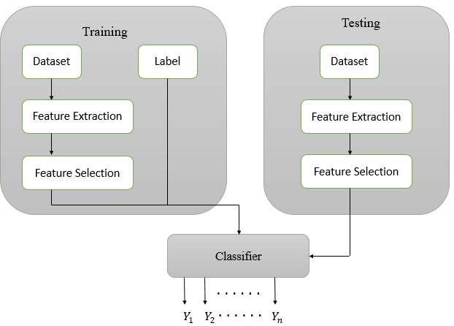

Fig.:- Block diagram of Multi-label Classifier

The input to the classifier is the image dataset for which labels must be assigned. Initially pre-processing is performed to extract a list of features. Though the non-informative features are removed.Before classification the most important words has to be identified which acts as features. Once the dataset has been obtained, it is imperative to perform some pre-processing in order to get the most significant images.After the images are pre-processed, the number of features in the document remains high and the high number of features is representative of the classification problem.

**PROGRESS UPDATE**

Preparation of the dataset which consists of 2 different folders for training and testing of data respectively. Each folder consists of 10 different classes which include images of: butterflies, chess, cups, food, landscape, plates,Pokémon, pollen grains, spoons, sports respectively.

First, we import some libraries-

Then we label the data-

We have to write a load_data function that load the images and the labels from the folder-

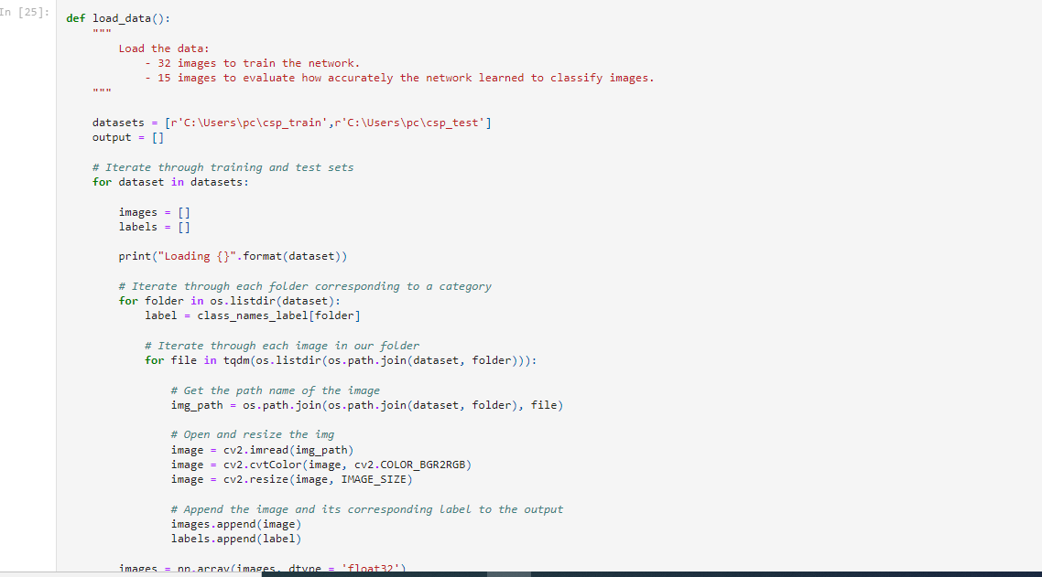

Training and Testing of the multilabel images using CNN machine learning algorithm-

Fig: Graph for training and testing of CNN model, Along x axis: Classes, Along y: axis: No of images

Fig: Pie Chart depicting proportion of each observed category

Fig: Model Accuracy graph

Fig: Model Loss graph

Preparation of **Survey Paper on different multi label classification**.

**RESULTS**

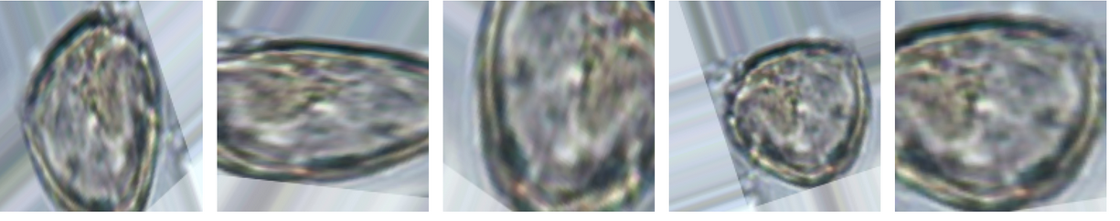

Fig: Augmented images for pollen grains class

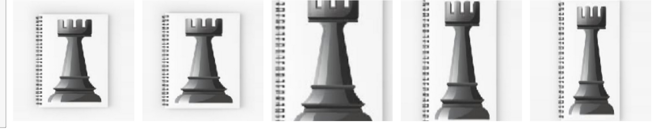

Fig: Augmented images for chess class

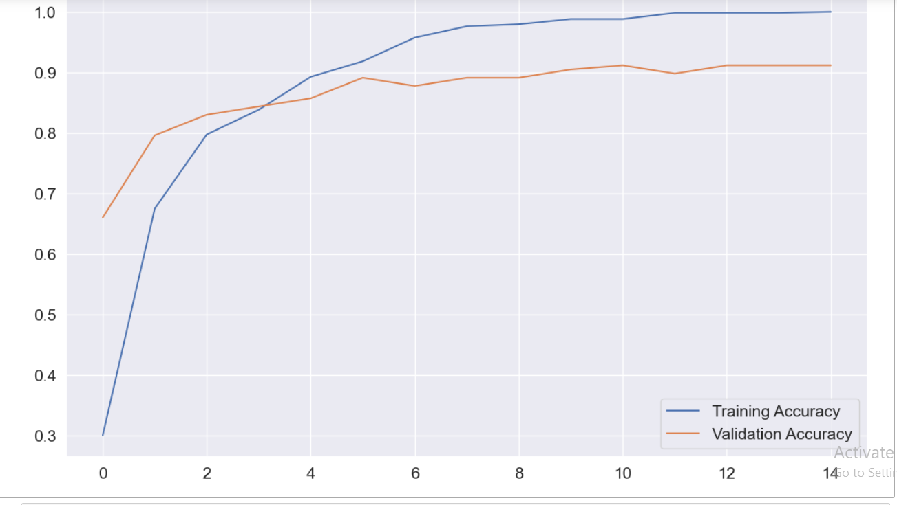

Fig: Training and Validation Accuracy graph

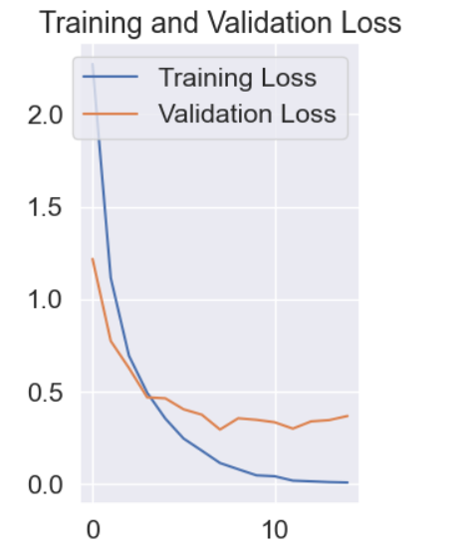

Fig: Training and Validation Loss graph

As we can notice here, the training and validation loss are both decreasing here and the training and validation accuracy is increasing together. That is the power of data augmentation.

**WORK TO BE DONE**

**Training and Testing** of the multi label images using **KNN** machine leaning algorithm.

**Comparison** between the results obtained via **CNN** and **KNN** machine learning algorithms.

**Preparation** and **publication** of the **research paper**.

**GANTT CHART**

|  |  |  |  |  |  |  |
| --- | --- | --- | --- | --- | --- | --- |
| **ACTIVITY** | **February 2022** | | **March 2022** | **April 2022** | **May 2022** | **June 2022** |
| **LITERATURE SURVEY** |  | | | | | |
|  |  |  | |  |  |
| **PROBLEM DEFINATION** |  |  |  | |  |  |
|  |  |  | |  |  |
| **DESIGN** |  |  | | |  |  |
|  |  |  |  |  |  |
| **IMPLEMENTATION** |  |  |  | | | |
|  |  |  |  |  |  |
| **TESTING** |  |  | |  |  | |
|  |  | |  |  |  |
| **REPORT AND DOCUMENTATION** |  | | | | | |
|  | |  |  |  |  |

**Proposed time frame for task completion Actual time frame for task completion**

**REFERENCES**

[1] Jiang Wang1 Yi Yang1 Junhua Mao2 Zhiheng Huang3∗ Chang Huang4∗ Wei Xu1 1Baidu Research 2University of California at Los Angles 3Facebook Speech 4 Horizon Robotics,” CNN-RNN:A Uniﬁed Framework for Multi-label Image Classiﬁcation”

[2] Lamia Nabil Mahdy,Kardy Ali Ezzat,Haytham H. Elmousalami, Hassan AboulElla,Aboul Ella Hassanien,Higher Technological Institute, Biomedical Engineering Department, Egypt, Faculty of Computers and AI, Cairo University, Cairo ,Egypt, Faculty of Veterinary medicine, Cairo University, Egypt,Scientific Research Group in Egypt(SRGE),”Automatic X-ray COVID-19 Lung Image Classification System Based on Multi-Level Thresholding and Support Vector Machine” http://www.egyptscience.net.

[3] Yan Luo(University of Minnesota), Mina Jiang (University of Minnesota),Qi Zhao(University of Minnesota),”Visual Attention in Mutli-Label Image Classification”, Authorized licensed use limited to: Cornell University Library. Downloaded on August 20,2020 at 09:19:17 UTC from IEEE Xplore.

[4] Francisco Gomez-Donoso, Félix Escalona, Ferran Pérez-Esteve, Miguel Cazorla, "Accurate Multilevel Classification for Wildlife Images", *Computational Intelligence and Neuroscience*, vol. 2021, Article ID 6690590, 11 pages, 2021. <https://doi.org/10.1155/2021/6690590>

[5] Decubber S., Mortier T., Dembczyński K., Waegeman W. (2019) Deep F-Measure Maximization in Multi-label Classification: A Comparative Study. In: Berlingerio M., Bonchi F., Gärtner T., Hurley N., Ifrim G. (eds) Machine Learning and Knowledge Discovery in Databases. ECML PKDD 2018. Lecture Notes in Computer Science, vol 11051. Springer, Cham. https://doi.org/10.1007/978-3-030-10925-7_18